Lysobacter agri sp. nov., a bacterium isolated from soil Hina Singh . KyungHwa Won . Juan Du . Jung-Eun Yang . Shahina Akter . Ki-Young Kim . Tae-Hoo Yi

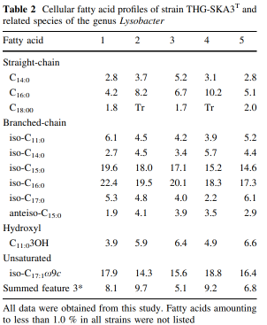

The predominant polar lipids are diphosphatidylglycerol, phosphatidylglycerol and phosphatidylethanolamine.

Lysobacter alkalisoli sp. nov., a chitin-degrading strain isolated from saline-alkaline soil Lian Xu, Xiao-Xian Huang, De-Liang Fan and Ji-Quan Sun\*

Профиль жирных кислот в клетках штамма SJ-36T характеризовался жирными кислотами изо-C15: 0 (37,5 %), суммарной характеристикой 9 (14,0 %; изо-C17: 1 ω9c и/или C16: 0 10-метил) и изо-C11: 0 (10,6 %).

Полярные липиды штамма SJ-36T состояли из фосфатидилэтаноламина (PE), дифосфатидилглицерина (DPG), фосфатидилглицерина (PG), двух неидентифицированных липидов (Ls) и неидентифицированного фосфолипида (PL). Штамм SJ-36T и два его ближайших родственника продемонстрировали очень похожие липидные профили, и все они имели PE, DPG, PG и L1. Однако PL2 присутствовал в L. maris KMU-14T и L. aestuarii S2-CT, но отсутствовал в штамме SJ-36T; L2 присутствовал в штамме SJ-36T, но отсутствовал в двух других штаммах; L3 присутствовал в штамме L. aestuarii S2-CT, но отсутствовал в L. maris KMU-14T и SJ-36T; PL1 присутствовал в SJ-36T и L. aestuarii S2-CT, но отсутствовал в L. maris KMU-14T (рис. S5).

Lysobacter antarcticus sp. nov., an SUF-system-containing bacterium from Antarctic coastal sediment

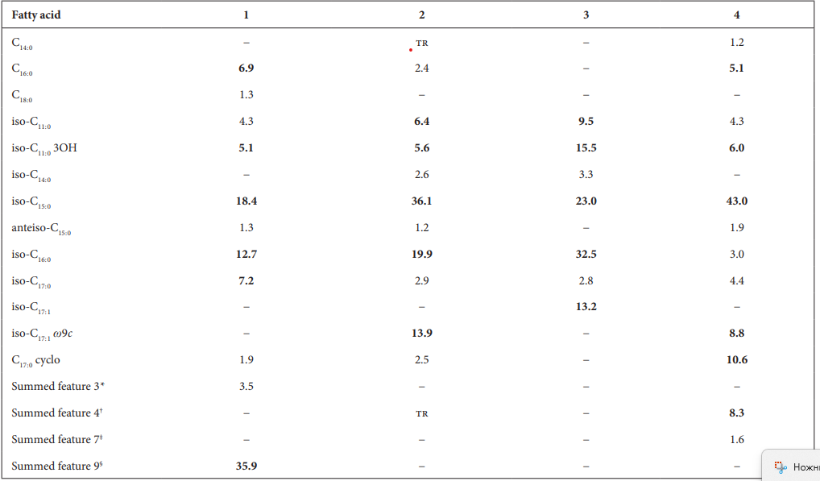

The major phospholipids found in strain GW1-59T were diphosphatidylglycerol, phosphatidylglycerol and phosphatidylethanolamine, which are commonly found in most Lysobacter species (Table 1, Fig. S6) [3]. Strain GW1-59T also contained three unidentified phospholipids and two unidentified lipids. The polar lipid profile of strain GW1-59T was clearly different from those of the reference strains. An unknown glycolipid was only detected in L. concretionis Ko07T . Phosphatidylmonomethylethanolamine, two unidentified aminophospholipids and an unidentified aminolipid were present in L. enzymogenes KCTC 12131T .

Lysobacter arenosi sp. nov. and Lysobacter solisilvae sp. nov. isolated from soil§

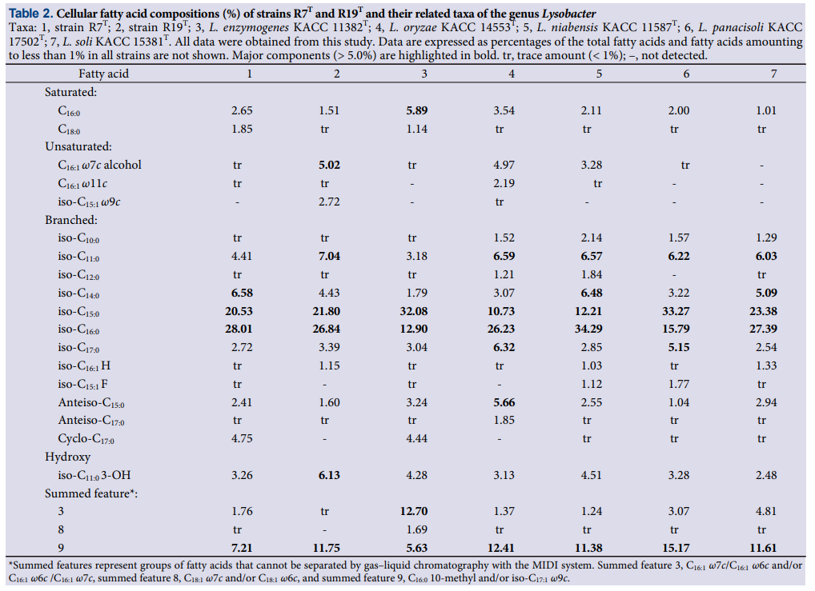

Both strains R7T and R19T contained PG, phosphatidylethanolamine (PE), and an unidentified phospholipid as the major polar lipids (Supplementary data Fig. S3). The presence of PG and PE in strains R7T and R19T was in agreement with other Lysobacter species members (Aslam et al., 2009; Zhang et al., 2019; Jin et al., 2020; Xu et al., 2021). However, DPG that has been reported as a major polar lipid in many Lysobacter species (Jeong et al., 2016; Im et al., 2020; Jin et al., 2020; Xu et al., 2021) was not detected in strains R7T and R19T (Supplementary data Fig. S4). However, because the absence of DPG has been also reported in some Lysobacter species (Aslam et al., 2009; Siddiqi and Im, 2016), which suggests that the presence of DPG is different depending on Lysobacter species.

Lysobacter arseniciresistens sp. nov., an arseniteresistant bacterium isolated from iron-mined soil Guosheng Luo, Zunji Shi and Gejiao Wang